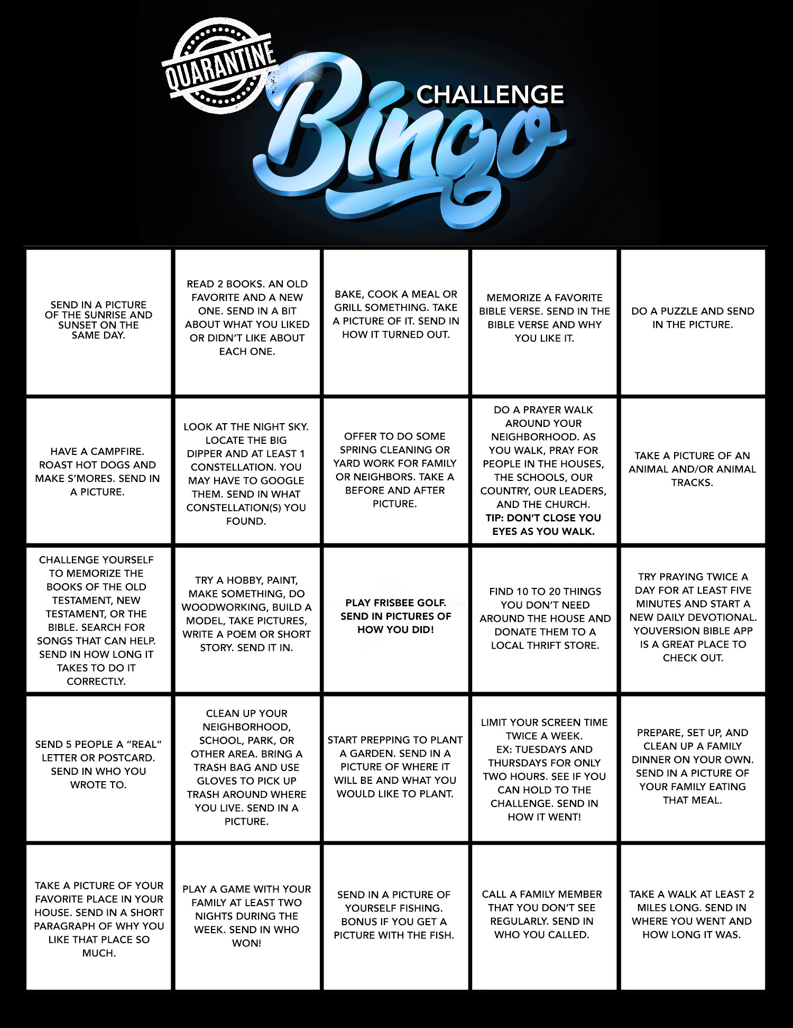

The Rules:
- This game starts on Sunday 04-05 and ends Sunday 04-12 at 1pm.
- You must send all pictures and info to the Youth Facebook page.
- Points will be given for finishing any row on the above board in a vertical, horizontal, or diagonal row of 5.
- BONUS points will be given to those youth who finish the entire board.
- Completion of any tile is based on a photo being submitted within the set time AND the judge’s decision.

